**Drone Detection Using Image Classification and Machine Learning**

**Final Year Project Report**

**Presented**

**by**

**Hamza Nadeem**

CIIT/FA20-BEE-063/ISB

**Khalid Syed Haleem**

CIIT/FA20-BEE-086/ISB

**Muhammad Bilal Babar**

CIIT/FA20-BEE-105/ISB

**Shahzaib Ali**

CIIT/FA20-BEE-230/ISB

**In Partial Fulfillment**

**of the Requirement for the Degree of**

***Bachelors of Science in Electrical Engineering***

**DEPARTMENT OF ELECTRICAL AND COMPUTER ENGINEERING**

COMSATS UNIVERSITY ISLAMABAD

July 2024

**Drone Detection Using Image Classification and Machine Learning**

**Final Year Project Report**

**Presented**

**by**

**Hamza Nadeem**

CIIT/FA20-BEE-063/ISB

**Khalid Syed Haleem**

CIIT/FA20-BEE-086/ISB

**Muhammad Bilal Babar**

CIIT/FA20-BEE-105/ISB

**Shahzaib Ali**

CIIT/FA20-BEE-230/ISB

**In Partial Fulfillment**

**of the Requirement for the Degree of**

***Bachelors of Science in Electrical Engineering***

**DEPARTMENT OF ELECTRICAL AND COMPUTER ENGINEERING**

COMSATS UNIVERSITY ISLAMABAD

July 2024

***Declaration***

*We, hereby declare that this project neither as a whole nor as a part there of has been copied out from any source. It is further declared that we have developed this project and the accompanied report entirely on the basis of our personal efforts made under the sincere guidance of our supervisor. No portion of the work presented in this report has been submitted in the support of any other degree or qualification of this or any other University or Institute of learning, if found we shall stand responsible.*

**Signature:** ______________

**Hamza Nadeem**

**Signature:** **______________**

**Khalid Syed Haleem**

**Signature:** ______________

**Muhammad Bilal Babar**

**Signature:** ______________

**Shahzaib Ali**

COMSATS UNIVERSITY ISLAMABAD

July 2024

*Drone Detection Using Image Classification and Deep Learning*

An Undergraduate Final Year Project Report submitted to the

Department of

**ELECTRICAL AND COMPUTER ENGINEERING**

**As a Partial Fulfillment for the award of Degree**

***Bachelors of Science in Electrical Engineering***

***by***

|  |  |
| --- | --- |
| **Name** | **Registration Number** |
| **Hamza Nadeem** | CIIT/FA20-BEE-063/ISB |
| **Khalid Syed Haleem** | CIIT/FA20-BEE-086/ISB |
| **Muhammad Bilal Babar** | CIIT/FA20-BEE-105/ISB |
| **Shahzaib Ali** | CIIT/FA20-BEE-230/ISB |

**Supervised by**

Dr. Junaid Ahmed

Associate Professor,

Department of Electrical and Computer Engineering

CU Islamabad

COMSATS UNIVERSITY ISLAMABAD

July 2024

***Final Approval***

*This Project Titled*

*Drone Detection Using Image Classification and Deep Learning*

*Submitted for the Degree of*

***Bachelors of Science in Electrical Engineering***

*by*

|  |  |
| --- | --- |
| **Name** | **Registration Number** |
| **Hamza Nadeem** | CIIT/FA20-BEE-063/ISB |
| **Khalid Syed Haleem** | CIIT/FA20-BEE-086/ISB |
| **Muhammad Bilal Babar** | CIIT/FA20-BEE-105/ISB |
| **Shahzaib Ali** | CIIT/FA20-BEE-230/ISB |

*has been approved for*

COMSATS UNIVERSITY ISLAMABAD

***Dedication***

This project is a tribute to our parents, whose unwavering support has been a guiding force in our journey. Their encouragement and emphasis on hard work during our engineering studies have been instrumental. They have not only provided us with financial and moral assistance but also shown keen interest in our aspirations, serving as a beacon of encouragement throughout our lives.

We also extend our gratitude to our esteemed supervisor, Dr. Junaid Ahmed, whose collaboration and guidance have been invaluable throughout the course of this project. Additionally, our friends and siblings have been constant pillars of support, offering encouragement and standing by us through every challenge and triumph.

Lastly, we dedicate this paper to the Almighty Allah. We acknowledge that our wisdom and capabilities are bestowed upon us by Allah. Without His divine will, our endeavors would be futile.

***Acknowledgements***

First and foremost, we express gratitude for the numerous blessings bestowed upon us by Allah Almighty, whose wisdom and knowledge enabled us to successfully complete this project.

Secondly, we extend our appreciation to our supervisor, Dr. Junaid Ahmed, for his exceptional mentorship and unwavering support throughout this endeavor.

Lastly, we recognize the invaluable support of our friends and family, whose words of kindness and unwavering presence have provided comfort, and whose enthusiasm for our achievements has served as a constant source of motivation.

|  |
| --- |
| **Hamza Nadeem** |
| **Khalid Syed Haleem** |
| **Muhammad Bilal Babar**  **Shahzaib Ali** |

***Table Of Contents***

1. **Introduction 12**
   1. Purpose 12
   2. Problem Statement 13
   3. Project Overview 13
   4. Expected Outcomes 15
   5. Targeted SDGs 16
2. **Literature Review 17**
   1. Drone Detection 17
   2. Related Work 18
   3. Comparison of Various Used Techniques 19
   4. Summary 20
3. **Project Methodology 21**
   1. Overview 21
   2. Model Selection 21
   3. Evaluation Metrics 26
   4. Data Acquisition and Preparation 27
   5. Model Selection 27
   6. Training the Model 28
   7. Model Evaluations 29
   8. Implementation 29

3.9 Ethical Consideration……………………………………….29

3.10 Hardware Integration………………….………………….29

3.11 Block Diagram……….………………….…………………32

**4. Evaluation, Testing, and Results 33**

4.1 Testing Procedure 33

4.2 Evaluation Metrics 34

4.3 Results 40

**5. Outcomes, Scope, and Conclusion 42**

5.1 Outcomes 42

5.2 Scope 43

5.3 Conclusion 45

**Bibliography 46 Appendix A 48**

***List of Acronyms***

UAV ……………………………………………………………………..Unmanned Aerial Vehicles

SOTA……………………………………………………………………………….State-of-the-Art

CNNs……………………………………………….……………...Convolutional Neural Networks

RF……………………………………………….…………………………………Radio Frequency

YOLO……………………………………………….………………………...You Only Look Once

SiLU……………………………………………….………………………….Sigmoid Linear Units

mAP……………………………………………….………………….…….mean Average Precision SPPF………………………………………….………………….……Spatial Pyramid Pooling Fast SPP………………………………………….………………….…………..Spatial Pyramid Pooling FPS………………………………………….………………….…………….…Frames Per Second

TP………………………………………….………………….…………………….…True Positive

FP………………………………………….………………….………………………False Positive

IoT……………………………………….………………….…………………….Internet of Things

CSI...………………………………….………………….…………………Camera Serial Interface R&D...………………………………….………………….……………Research and Development

|  |
| --- |
| **Figure 01:** Basic CNNs architecture…………………………………...………………………….21 **Figure 02:** Structure mainly consists of backbone, neck, and head……………………….………22 **Figure 03 ( a, b, c, d, e, f ):** The network structure of YOLOv8..........……………………..……23 **Figure 04:** YOLOv8 network structure diagram………………………………..…………………25 **Figure 05 ( a ):** Raspberry pi 4 module.….…...………………………...…………………………30 **Figure 05 ( b ):** Raspberry pi camera module (P5VO4A).….………..…………………………... 32 **Figure 06:** Hardware integration block diagram......…………………...………………………… 32 **Figure 07:** Detection on custom test-set...……………………………...………………………….33 **Figure 08:** Detecting drone and bird on test image..…………………...………………………… 34 **Figure 09:** Confusion matrix for drones vs birds.……………………...………………………… 35 **Figure 10:** F1 curve for drones vs birds...……………………………...………………………… 36 **Figure 11:** Precision recall curve……….……………………………...…………………………..37 **Figure 12:** Recall-confidence curve…….……………………………...………………………….38 **Figure 13:** Precision-confidence curve………………………………...…………………………..39 **Figure 14 ( a ):**  Figure shows epochs on X axis and Training Losses on Y axis.…………….....……40 **Figure 14 ( b ):**  Figure shows epochs on X axis and Validation Losses on Y axis.…………….....…40 **Figure 14 ( c ):**  Figure shows epochs on X axis and Precision and Recall values on Y axis.…………41 **Figure 14 ( d ):**  Figure shows epochs on X axis and mAP50 and mAP50-95 on Y axis.……………..41 |

***List of Figures***

***List of Tables***

**Table 01:** Comparison of different methodologies ………………………………….…………...19

***Abstract***

As drones become more widely available, reports of drone invasions have increased recently. The misuse of drones endangers the privacy and safety of the general public. Conventional anti-drone systems locate drones using a wide range of radio-frequency sensors. The thesis aims to assess the most advanced models and training approaches for drone identification.

Running the model in real-time and recognizing small drone targets at a distance were the two key problems in this thesis. Since it is hard to locate a publicly accessible dataset of tiny drones online, this thesis made use of a real-world small drone dataset. The real-world dataset was used to test and compare various iterations of pre-trained models. To investigate their impact on small item detection, the models' detecting heads were modified. Different sources of images were used for training and comparison with the trained model. Different methods were used to add bird photos to the training dataset to lower the number of false positives that occurred when birds were present in the test set.

The primary aim is to evaluate cutting-edge models and training techniques for effective drone detection, particularly targeting the challenge of identifying small drones at extended distances in real-time scenarios. To overcome the scarcity of publicly available datasets, a bespoke dataset of real-world small drones was meticulously constructed and utilized for rigorous testing.

.

**Chapter 01**

**Introduction**

Due to their wide accessibility, Unmanned Aerial Vehicles (UAVs), referred to as drones, are becoming more of a threat to critical infrastructure, such as prisons, power plants, airports, and government sites. Traditional drone tracking systems use radio-frequency detection or radar, but these technologies frequently malfunction in places where there is signal interference or when the transmission is blocked. The focus on drone identification and surveillance is increasing as drone usage keeps rising. The purpose of this thesis is to assess drone detection efficacy using state of the art (SOTA) models and different training strategies.

* 1. **Purpose:**

The goal is to examine cutting-edge (SOTA) machine learning models and diverse methods of training on a range of datasets to detect drones. As drone technology is growing at a greater pace and being used around both commercial and recreational use, the issues related to monitoring and managing the devices have largely increased.

Our focus is to find the answers to the challenges with an analysis of the efficiency of existing models developed for drone-based surveillance and an assessment of their accuracy, responsiveness, and practical capability to implement in actual environments. Through such an in-depth analysis and advice, this research puts itself forward as a necessary bridge between theoretical research and practical, operational solutions to be found in this burgeoning area of drone surveillance.

This study is driven by the pressing need for effective drone detection systems amidst the rising use of drones across various sectors, coupled with escalating security concerns. As drones become more accessible and versatile, the potential for misuse or intrusion grows, necessitating robust surveillance measures. Traditional detection techniques often prove costly and inadequate for addressing modern drone threats. Therefore, this research aims to explore cost-effective alternatives, leveraging state of the art machine learning models and innovative training strategies. By developing and evaluating these methods, the study seeks to provide practical solutions for enhancing security and privacy in drone-populated environments, offering a vital response to the evolving landscape of drone usage and associated security challenges.

* 1. **Problem Statement:**

The extent of drones across various industries and recreational activities has led to an increase in security concerns, as traditional detection methods struggle to effectively monitor and mitigate potential threats posed by these unmanned aerial vehicles (UAVs). Furthermore, the high cost and limited scalability of existing detection technologies present significant barriers to widespread implementation. Consequently, there is a critical need for cost-effective and reliable drone detection systems capable of accurately identifying and tracking UAVs in real-time, addressing both security and privacy concerns[1].

* 1. **Project Overview:**

The main goals are to maximize detection accuracy, assess the viability of deployment in a variety of situations, and examine the real-time drone detection capabilities of different models. By doing this, the project hopes to improve privacy and security in places where drone intrusions are a possibility while providing reasonably priced solutions that can be quickly implemented in a variety of industries. In addition, the project intends to furnish stakeholders interested in drone detection system implementation with a thorough guide and to add significant insights to the academic community.

* **Objectives:**

**Exploration of Cutting-Edge Models:** This project primarily aims to rigorously investigate state of the art machine learning models and a variety of training techniques tailored for drone detection. The research will thoroughly evaluate the capability of these models to precisely detect and track drones under various operational conditions, emphasizing their accuracy and adaptability to different environmental challenges and drone behaviors, thereby enhancing drone surveillance technologies.

**Improvement of Detection Accuracy:** A central goal is to markedly improve the accuracy of drone detection systems. This includes refining the functionalities of existing models, such as optimizing detection algorithms and integrating innovative methods like dataset segmentation. These advancements are designed to heighten the precision in identifying small drones at greater distances, minimizing false positives, and bolstering the reliability of the detection systems.

**Assessment of Deployment Feasibility:** This objective focuses on evaluating the feasibility and scalability of these enhanced detection systems for practical implementation in a variety of environments. It involves rigorous testing of the models’ performance and responsiveness across diverse scenarios to ensure they meet the operational demands and maintain effectiveness in real-world conditions.

* + - **Impacts:**

**Strengthened Security and Privacy:** By advancing drone detection technology, this project aims to significantly strengthen security and privacy in areas susceptible to unauthorized drone activities. Enhancements in detection systems will help secure public venues, critical infrastructure, and private properties, enabling preemptive actions against potential intrusions and thus safeguarding these environments.

**Development of Economical Solutions:** The research strives to produce cost-effective drone detection solutions that encourage widespread adoption. By creating scalable and affordable technologies, the project will support a variety of stakeholders, from large corporations to smaller entities and individuals, in managing the security challenges brought about by the proliferation of drone technology.

**Increased Operational Efficiency:** Robust drone detection systems are vital for maintaining operational efficiency in drone-prevalent areas. The project is geared towards enabling proactive surveillance and quick responses to drone-related threats, which helps avoid operational disruptions and ensures continuous activity flow. These systems are not only beneficial for security but also enhance monitoring and resource management.

**Contribution to Academic and Practical Knowledge:** This project is set to contribute significantly to both the academic field and practical applications of drone detection technology. Through detailed research and analysis, it will enrich the body of knowledge, offering insights and data crucial for future innovations and methodological advancements in drone surveillance.

**Technological Innovations:** This research is expected to lead to substantial technological innovations by applying novel machine learning approaches to drone detection. This exploration will push the boundaries of current capabilities, fostering the development of more sophisticated, efficient, and adaptable drone detection systems.

**Influence on Policy and Regulations:** The findings from this study could have a profound impact on policy-making and regulatory standards related to drone operations. By providing comprehensive and reliable data, the research could help shape informed, balanced policies that promote safety and innovation in the use of drone technology.

* 1. **Expected Outcomes:**
     + **Fine-Tuned Pretrained Model:**

One of the primary expected outcomes of this project is the successful fine-tuning of a pretrained machine learning model on a custom dataset tailored for drone detection. Through meticulous training and optimization processes, we anticipate achieving significant improvements in the model's ability to accurately identify and track drones, particularly small targets at extended distances.Building upon the fine-tuning process, we expect to yield promising results in terms of detection accuracy and reliability. By leveraging innovative techniques such as dataset tiling and modification of detection heads, we anticipate overcoming the challenges associated with detecting small drones and mitigating false positives.

* + - **Real-Time Detection Integration:**

Another crucial expected outcome is the successful integration of the trained model into a real-time detection system. By optimizing the model's responsiveness and efficiency, we aim to enable seamless and instantaneous drone detection, facilitating proactive monitoring and timely response to potential threats in dynamic environments. Intention is to develop drone detection technology that can be both practical and effective enough to be deployed in a variety of real-world scenarios. This includes considerations for scalability, adaptability to varying environmental conditions, and ease of integration with existing surveillance infrastructure.

* + - **Validation and Evaluation:**

Finally, we expect to thoroughly validate and evaluate the working of the developed drone detecting system through comprehensive testing and validation procedures. This includes rigorous assessment of detection accuracy, responsiveness, and robustness under different scenarios, ultimately ensuring the reliability and effectiveness of the solution in enhancing security and privacy in drone-frequent environments.

* 1. **Targeted SDGs :**
* **SDG 9:** **Industry, Innovation, and Infrastructure**

Contributes to innovation in surveillance technology and infrastructure by developing a novel approach to drone detection using advanced image classification and deep learning techniques.

* **SDG 11:** **Sustainable Cities and Communities**

Effective drone detection enhances security and safety within urban areas, contributing to the creation of resilient and sustainable cities.

* **SDG 16: Peace, Justice, and Strong Institutions**

Drone detection systems play a crucial role in ensuring security and law enforcement, promoting peace and justice within communities, and strengthening institutional capacities for safety and surveillance.

* **SDG 17: Partnerships for the Goals**

Collaboration with stakeholders, including government agencies, law enforcement, and technology providers, is essential for the successful implementation and adoption of drone detection systems, highlighting the importance of partnerships for achieving sustainable development objectives.

**Chapter 02**

**Literature Review**

* 1. **Drone Detection:**

Both industrial and academic methods for detecting drones include non-optical techniques such as acoustics, radar, and radio frequency, as well as optical methods that rely on identifying drones based on features extracted from images and videos.

* + - **Non-Optical Approaches**

The distinctive acoustic signatures produced by drone rotors can aid in distinguishing drones from their surroundings. Microphone arrays capture various sounds, including those generated by drones, airplanes, birds, and thunderstorms, which are then analyzed by algorithms to identify drones based on high frequency features. This method is impractical in noisy environments such as airports and urban areas. Radar detection, traditionally used for larger aerial vehicles like airplanes, has been adapted to detect shifts of the frequency in wing motions and drone rotors. Yet, these modifications may introduce additional noise, complicating the differentiation between birds, drones, and background clutter. RF detection relies on capturing and analyzing the RF signals used by drones to communicate with ground pilots and transmit video feeds. This method, which can be effectively conducted over long distances, is commonly employed for drone detection in various markets.

* + - **Optical Approaches**

Compared to previously discussed methods, optical approaches offer greater convenience, intuitiveness, and cost-effectiveness. These approaches can be categorized based features extracting for object classification and detection. Traditional optical methods rely on manually extracted techniques and machine learning algorithms. Initially, methods like background subtraction are used to identify areas of interest, but these methods often exhibit less recognition rates comparing to deep-learning methods. Contemporary optical approaches utilize deep-learning for object-detection, which has become increasingly prevalent. Deep learning methods employ convolutional layers to extract higher level semantic features from images, surpassing the capabilities of handcrafted feature extraction. Consequently, deep learning yields superior hierarchical features. Numerous states of the art (SOTA) models have been evaluated and compared for drone detection tasks. This thesis aims to assess and compare new SOTA object detection models based on specific drone detection requirements.

* 1. **Related Work:**

Following are some studies conducted in the area of efficient task offloading in chronological order:

In 2017, a paper titled " A study on detecting drones using deep convolutional neural networks " by Saqib M, Khan SD, Sharma N, Blumenstein M examined the efficacy of deep learning object detection methods for drones employing different CNN-based architectures such as VGG16. Utilizing transfer learning and assessing mean Average Precision, VGG16 with Faster R-CNN exhibited superior performance on the training dataset. [7]

In 2019, a study published in IPSJ Transactions on Computer Vision and Applications titled " Deep learning-based strategies for the detection and tracking of drones using several cameras " by Unlu, E. Zenou, N. Riviere, and P.-E. Dupouy aimed to create an independent drone surveillance system utilizing RGB cameras and computer vision. They achieved this by employing a lightweight YOLOv3 architecture for detection and introducing an innovative multi-camera overlay technique. [8]

In September 2023, Shafiq, K. published a dissertation titled " Drone Detection and Classification using Machine Learning (Doctoral dissertation, Université d ‘Ottawa/University of Ottawa) " from Université d'Ottawa/University of Ottawa. The dissertation investigates the integration of deep-learning-based detection algorithms into RF anti-drone systems to counter the rising incidents of drone intrusions. Assessing different versions of YOLO on an actual dataset, YOLOv5n and YOLOv5m exhibit notable performance, particularly enhanced by techniques like tiling and incorporating background bird images to improve detection accuracy. [9]

In February 2023, a paper authored by Liu, Y. titled " Drone Detection using Deep Learning " prioritized the assessment of inference speed, precision, and accuracy as primary evaluation criteria. YOLOv5n and YOLOv5m were identified as preferred options, with YOLOv5n showcasing superior real-time performance, particularly with the implementation of image tiling to improve recall. Additionally, ensuring dataset consistency and incorporating images of birds were found to enhance precision and recall. [10]

* 1. **Comparison of various used techniques:**

A comparison of the different methodologies used regarding efficient task offloading using fog computing is given below.

|  |  |  |  |  |
| --- | --- | --- | --- | --- |
|  | **Techniques used.** | **Objective.** | **Advantages.** | **Limitations.** |
| **1.** | Radiofrequency (RF) Sensors.[11] | Locating drones by detecting their radio signals. | Effective in detecting drones based on their radio signals. Widely used in traditional anti-drone systems. | Limited to detecting drones emitting radio signals. Susceptible to signal interference and jamming. |
| **2.** | Acoustic Sensors.[2] | Detecting drones based on the sound they produce. | Can detect drones even if they are visually obscured. And provide information about the drone's size and movement. | Limited range compared to other detection methods. Susceptible to background noise and false positives. |
| **3.** | Radar Systems.[3] | Using radar to detect drones by analyzing their radar cross-section. | Can detect drones regardless of visual or radio signal detection. Also tell about drone's speed, altitude, and direction. | Expensive and requires specialized equipment also affected by weather conditions. |
| **4.** | Surveillance Cameras with Deep Learning Algorithms.[10] | Utilizing deep learning algorithms on surveillance footage to detect drones. | Offers potential for real-time detection. Can detect drones visually, regardless of radio signal emissions. | Requires extensive training data for effective model performance.  Limited by factors such as lighting conditions and camera angles. |

**Table 01:** Comparison of different methodologies

* 1. **Summary:**

Various techniques utilized for drone detection, highlighting both non-optical and optical approaches are discussed. Non-optical methods, including acoustic, radar, and radio frequency detection, offer effectiveness but face limitations such as susceptibility to noise and interference. In contrast, optical approaches, particularly those employing deep learning, provide convenience and improved accuracy. The review emphasizes the evolution from handcrafted feature extraction to deep learning methods, showcasing advancements in object detection algorithms.

Moreover, the related work section outlines notable studies in the field, spanning from evaluations of deep learning object detection techniques to the development of autonomous drone surveillance systems. These studies demonstrate the effectiveness of models like YOLOv3 and YOLOv5 in real-time drone detection, leveraging techniques such as image tiling and background bird images to enhance accuracy and recall.

Furthermore, a comparison of various methodologies used in efficient drone detection underscores the trade-offs between objectives, advantages, and limitations. Techniques prioritize energy minimization, fairness in task allocation, minimizing delay, or optimizing resource utilization. Each approach offers unique benefits but also faces challenges such as communication overhead or scalability issues.

Overall, a comprehensive overview of the current state of drone detection techniques, highlighting advancements, challenges, and opportunities for future R&D in the field are considered.

**Chapter 03**

**Project Methodology**

* 1. **Overview:**

This section outlines the comprehensive methods employed in the development of an image classification system for drone detection. The approach is structured to harness the power of deep learning using a pre-trained model, customized to effectively identify drones in various operational environments.

**3.2. Model Selection**

* **Convolutional Neural Networks (CNNs):**

Convolutional Neural Networks (CNNs) have become an effective tool for image classification applications, such as drone detection. CNNs are particularly well-suited for jobs where the input data has a grid-like structure, like photographs, because of their ability to capture spatial hierarchies and patterns within images.

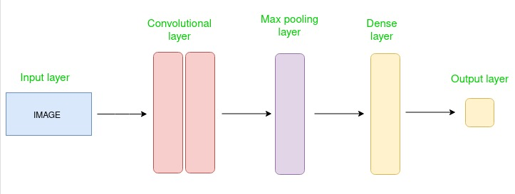

**Figure 1:** Basis CNNs Architecture .

Convolutional, pooling, and fully linked layers make up the hierarchical layer structure used by CNNs. CNNs may automatically learn hierarchical characteristics from raw pixel values thanks to this architecture; these features can range from basic elements like textures and edges in lower layers to more intricate abstract features in deeper layers. CNNs leverage parameter sharing, which significantly reduces the number of parameters compared to fully connected networks. By sharing weights across spatial locations, CNNs can efficiently learn from local patterns, leading to better generalization and reduced risk of overfitting, especially when dealing with limited training data. CNNs can scale to accommodate large and high-dimensional datasets, making them suitable for real-world applications with extensive image data. There are many CNNs models like ResNet, DenseNet and YOLO version (v3, v5, v8).

* **YOLOv8 Detection Algorithm**

The YOLOv8 has notably advanced the field of computer-vision, leading researchers to enhance and introduce new modules to the framework, resulting in various iterations. YOLOv8, launched by Ultralytics on January 10, 2023, represents a significant progression compared to earlier models like YOLOv5 and YOLOv7. It boasts superior detection accuracy and speed, establishing itself as a state of the art model in the YOLO series.

Top of Form

**Figure 2:** Structure mainly consists of the backbone, neck, and head.

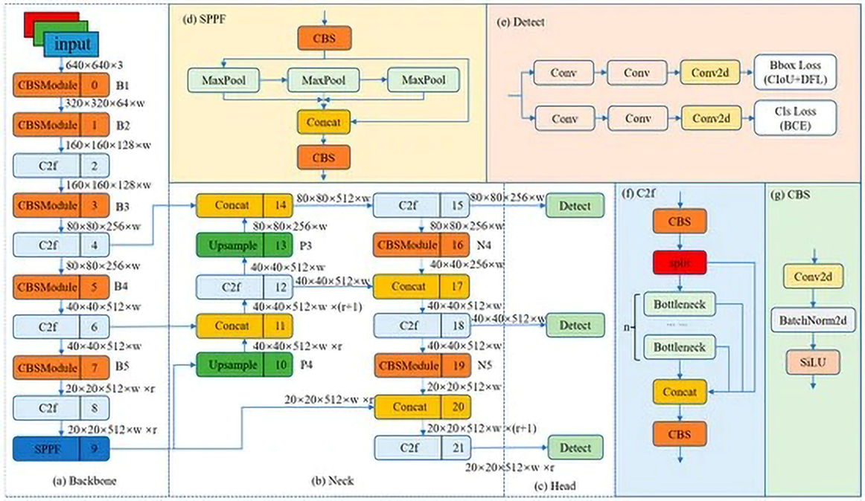

**Figure 3 ( a, b, c, d, e, f, g ) :** The network structure of YOLOv8. The w (width) and r (ratio) are parameters used to represent the size of the feature map. The size of the model can be controlled by setting the values of w and r to meet the needs of different application scenarios.

**1) Backbone :** Five stages of down sampling are applied to the input features in order to produce five unique scale features, denoted as B1–B5. Figure 2a shows the structure of the backbone network. As shown in Figure f (where 'n' denotes the number of bottlenecks), the C2f module is used in place of the Cross Stage Partial module that was originally part of the backbone network. To improve information flow inside the feature extraction network without sacrificing lightweight construction, the C2f module has a gradient shunt connection. As shown in Figure 1g, the output result is obtained by the Clustered blueprint Separatable module by performing a convolution operation on the input data, followed by batch normalization and activation using SiLU. Utilizing the SPPF module to combine the input feature maps into a fixed-size map for adaptive size output is the last step in the backbone network architecture. As illustrated in Figure 1d, SPPF, as opposed to the SPP structure, lowers computational complexity and latency by successively connecting three maximum pooling layers.

Top of Form

**2) Neck :** YOLOv8 has a PAN-FPN structure in its neck, as shown in Figure 1b, which was inspired by PANet [33]. YOLOv8 maintains original performance while creating a more lightweight model by doing away with the convolution operation post up-sampling in the PAN structure, in contrast to the neck structure of YOLOv5 and YOLOv7 models. P4-P5 and N4-N5, respectively, stand for the two distinct feature scales seen in the YOLOv8 model's FPN and PAN structures. In traditional FPN, semantic information is strengthened by combining B4-P4 and B3-P3, albeit at the expense of certain object localization information. This top-down technique is used to express deep semantic information. By integrating PAN and FPN, PAN-FPN resolves this problem. PAN improves location information learning by combining P4-N4 and P5-N5 to enable top-down path enhancement. By creating a network topology that is both top-down and bottom-up, PAN-FPN ensures feature diversity and completeness by combining deep semantic information with shallow positional information through feature fusion.

**3) Head:** As shown in Figure 1e, a decoupled head structure is used in the YOLOv8 detection component. For object classification and bounding box regression prediction, this structure uses two separate branches, each with a different set of loss functions that are specific to the tasks at hand. Model convergence is accelerated, and detection accuracy is improved by this detection architecture. A detection model that does not rely on anchors is used by YOLOv8 to accurately identify positive and negative samples. Furthermore, it makes use of the Task-Aligned Assigner to dynamically assign samples, improving the model's robustness and detection accuracy.Top of Form

* **Method :**

With three scale-detection layers to handle objects of different sizes, YOLOv8 is a state of the art object recognition model created to address the multiscale nature of things. Nevertheless, the model has difficulties in UAV aerial photography scenarios because of the intricate backgrounds and the high density of little items. In order to tackle these problems, our work builds upon the basic architecture of YOLOv8 and refines its multiscale feature fusion, attention mechanism, and loss function. By adding new features and optimizations to boost performance and versatility, this builds on the success of earlier YOLO versions and achieves exceptional speed and accuracy. YOLOv8 provides five distinct model sizes: nano, small, medium, big, and extra-large, to accommodate a range of deployment requirements. With approximately 3.2 million parameters, the Nano model is especially well-suited for deployment on mobile and CPU-only devices. This study uses YOLOv8s, a variation that is created by expanding and spreading the nano network structure, as the model for UAV identification to achieve a balance between detection accuracy and speed. The backbone, neck, and head of YOLOv8 are responsible for feature-extraction, multi feature fusion, and predictions, respectively.

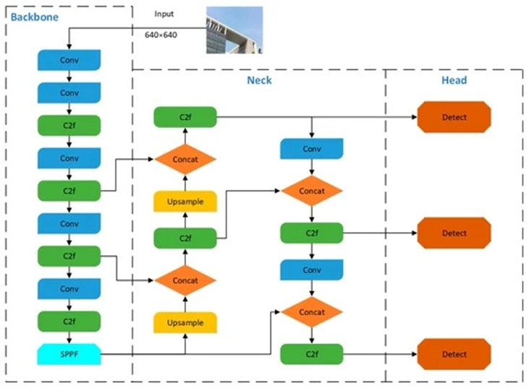

**Figure 4 :** YOLOv8 network structure diagram.

**3.3.**  **Evaluation Metrics :**

Experimental evaluation metrics such as Recall (R), Precision (P), Average Precision, F1 score, mean Average Precision (mAP), number of parameters, model size, and frames per second (FPS) are selected to validate the model’s performance.

* Accuracy, recall and F1 score are calculated as follows:

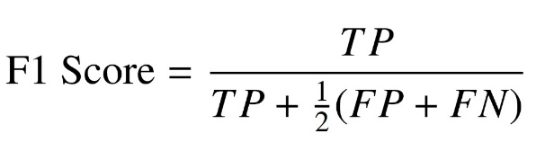

TP (true positives) refers to the correctly identified targets, FP (false positives) represents the instances where backgrounds are incorrectly identified as targets, and FN (false negatives) indicates the count of targets that are mistakenly identified as backgrounds. The average precision and average precision mean are calculated as follows:

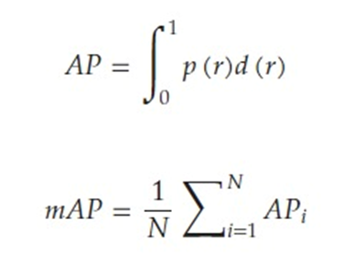

In this context, N represents the number of categories, and AP stands for the average accuracy of each category. For our UAV detection task, we have N = 1, indicating there is only one category.

**3.4.**  **Dataset Acquisition and Preparation**

* **Dataset Collection:**

The project utilizes a meticulously compiled dataset comprising 6,954 images of various drone models captured under different environmental conditions. These images were sourced from publicly available drone image databases and augmented by a series of field captures conducted in controlled airspace environments to ensure a variety of backgrounds and drone sizes. The diversity in the dataset is intended to mimic real-world scenarios, enhancing the robustness of the model.

* **Custom Dataset:**

Additionally, a custom dataset comprising 1000 images was meticulously curated, encompassing varied backgrounds and lighting conditions to ensure robustness and diversity in training the detection models. Each image in the dataset was meticulously annotated to delineate the precise location and boundaries of drones, facilitating supervised learning and model training. This comprehensive dataset serves as a vital resource in evaluation and optimization of the detection algorithms, enabling the models to effectively recognize drones across different environmental settings and lighting conditions.

* **Preprocessing Steps:**

Each image in the dataset was resized to a uniform dimension to standardize input size for the neural network. A normalization process was applied to scale pixel values to a [0,1] range, which helps in speeding up the convergence during training. Data-augmentation techniques such as rotating, scaling, and horizontal, vertical flipping were employed to increase dataset variability and prevent overfitting.

**3.5 Model Selection**

* **Preprocessing Steps:**

Considering the complexity of drone detection, Convolutional Neural Networks (CNNs) were chosen due to their proven effectiveness in image recognition tasks. Specifically, models such as ResNet-50 and YOLO (You Only Look Once) were evaluated due to their speed and accuracy in object detection tasks (Redmon et al., 2016).

* **Model Customization:**

The YOLOv8 model was fine-tuned and customized to better suit drone image classification. The top layers of the YOLOv8 architecture were modified to accommodate the specific requirements of drone detection. In particular, the last layer of the YOLOv8 model was interchanged with a SoftMax layer tailored to classify images into two classes: drone and no-drone.

**3.6 Training the Models:**

* **Training Environment:**

The model was trained utilizing YOLO, a robust framework that streamlines the creation, training, and validation of deep learning models. Training procedures were conducted on a workstation featuring an NVIDIA GTX 1080 Ti GPU, greatly expediting the training process.

* **Training Process:**

The dataset was split into training, validation, and testing sets with proportions of 70%, 15%, and 15%, Correspondingly. This allocation makes sure that model undergoes evaluation on unseen data, thereby offering an authentic assessment of its performance. During training, batch size of 64 and a learning rate of 0.0001 were employed, with early stopping implemented to prevent overfitting.

* **Challenges and Solutions:**

One significant challenge was the variance in lighting conditions in the images, which initially led to poor model performance under low light. This issue was mitigated by including night-time images in the training set and applying histogram equalization as a preprocessing step to enhance image contrast.

**3.7 Model Evaluation:**

* **Evaluation Metrics:**

Model performance was primarily assessed using accuracy, recall, precision and F1-score. These metrics are critical for evaluating model's effectiveness in correctly identifying drones versus false detections (Powers, 2011).

**3.8 Implementation:**

* **Real-time Detection:** The fine-tuned model was deployed into a real-time detection system using OpenCV and Python. The system processes video feed from a standard surveillance camera, applies the detection model frame-by-frame, and flags the presence of drones with bounding boxes.
* **Testing and Validation:** The system was field-tested in various scenarios, including populated urban areas and near airport environments. Feedback from these tests was used to refine the model iteratively.

**3.9 Ethical Considerations:**

Ethical implications were carefully considered, especially regarding privacy concerns in public areas. All dataset images were collected with appropriate permissions, and real-time testing was conducted in compliance with local regulations regarding surveillance and drone operation. This methodology ensures a robust, ethically compliant approach to developing a drone detection system that could significantly enhance security protocols in sensitive areas.

**3.10 Hardware Integration:**

Integrated the YOLOv8 model onto a Raspberry Pi, enabling real-time detection using a camera module, Following are the specifications of the hardware used.

* **Raspberry-pi 4 Model B:**

The Raspberry-Pi 4 Model B is a impressive single board computer known for its versatility and performance. Here are its specifications:

* **Processor:** Broadcom BCM2711, Quad-core Cortex-A72 (ARM v8) 64-bit SoC @ 1.5GHz.
* **Memory (RAM):** Options for 2GB, 4GB, or 8GB LPDDR4-3200 SDRAM.
* **Connectivity:**
* 2.4GHz and 5.0 GHz IEEE 802.11ac wireless, Bluetooth 5.0, BLE.
* Gigabit Ethernet.
* 2x USB 3.0 ports, 2x USB 2.0 ports.
* 2x Micro HDMI ports (up to 4Kp60 supported).
* MIPI DSI display port, MIPI CSI camera port, 4-pole stereo audio and composite video port.
* **Multimedia:** H.265 (4Kp60 decode), H.264 (1080p60 decode, 1080p30 encode), OpenGL ES 3.0 graphics.
* **GPIO (General Purpose Input/Output):** 40-pin GPIO header, supporting GPIO, SPI, I2C, UART, PWM.
* **Storage:** MicroSD slot for operating system and data storage.
* A green circuit board with many ports

  Description automatically generated**Operating-System Support:** Compatible with a wide range of operating-systems, including Raspberry Pi OS (formerly Raspbian), Ubuntu, and various Linux distributions.

**Figure 5 ( a ):** Raspberry pi 4 Module.

The Raspberry-Pi 4 Model B represents a substantial advancement in performance, connectivity, and multimedia capabilities over its previous iterations, rendering it well-suited for various applications such as desktop computing, do-it-yourself (DIY) projects, and Internet of Things (IoT) solutions.

* **Raspberry-Pi Camera Module (P5VO4A) :**

The Raspberry-Pi Camera Module (P5VO4A) is a compact and versatile imaging solution designed specifically for use with Raspberry Pi single-board computers. Here are its specifications:

* **Sensor:** Omni Vision 5647 sensor.
* **Resolution:** Capable of capturing still images at 5 megapixels (2592 x 1944 pixels).
* **Video Resolution:** Supports video recording at various resolutions and frame rates, including:
* 1080p HD video recording at 30 frames per second (fps).
* 720p HD video recording at 60 fps.
* 640x480p video recording at 60 or 90 fps.
* **Lens:** Fixed focus lens onboard.
* **Interface:** Connects directly to the Raspberry-Pi via a 15-pin MIPI Camera Serial Interface (CSI) connector.
* **Compatibility:** Supported in the latest version of Raspbian (now known as Raspberry-Pi OS), the preferred operating system for Raspberry-Pi.
* **Dimensions:** Compact design measuring approximately 25mm x 20mm x 9mm.
* **Weight:** Lightweight construction, weighing just over 3 grams.
* **CSI Interface:** The CSI interface provides high-speed data transmission exclusively for pixel data to the Raspberry-Pi's BCM2835 processor.

The Raspberry-Pi Camera Module (P5VO4A) offers high-quality imaging capabilities, making it suitable for various applications, including photography, video recording, surveillance, and machine vision projects. Its compatibility with Raspberry Pi single-board computers ensures seamless integration and ease of use for hobbyists, educators, and professionals alike.

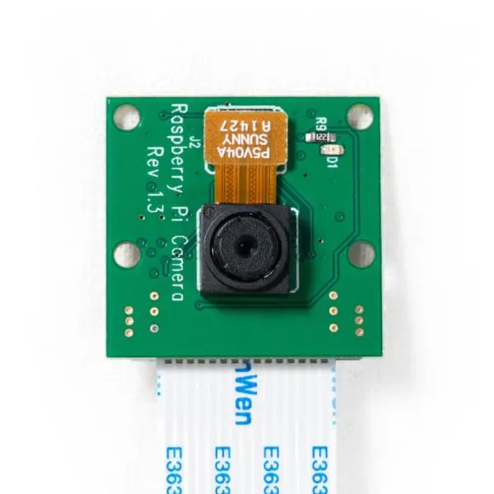

**Figure 5 ( b ):** Raspberry Pi Camera Module (P5VO4A).

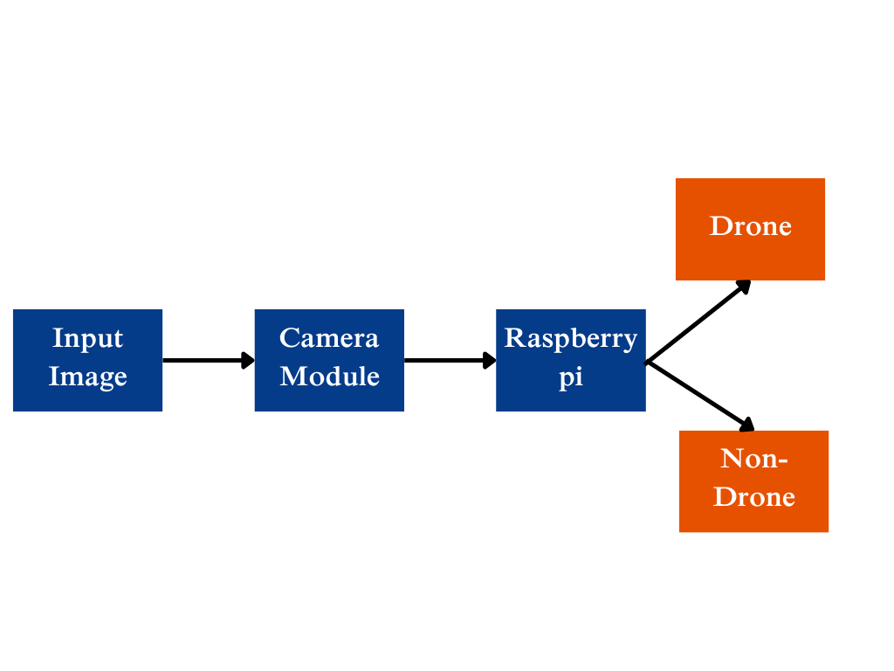**3.11 Block Diagram:**

**Figure 6:** Hardware integration block diagram.

**Chapter 04**

**Evaluation, Testing and Results**

* 1. **Testing Procedure:**

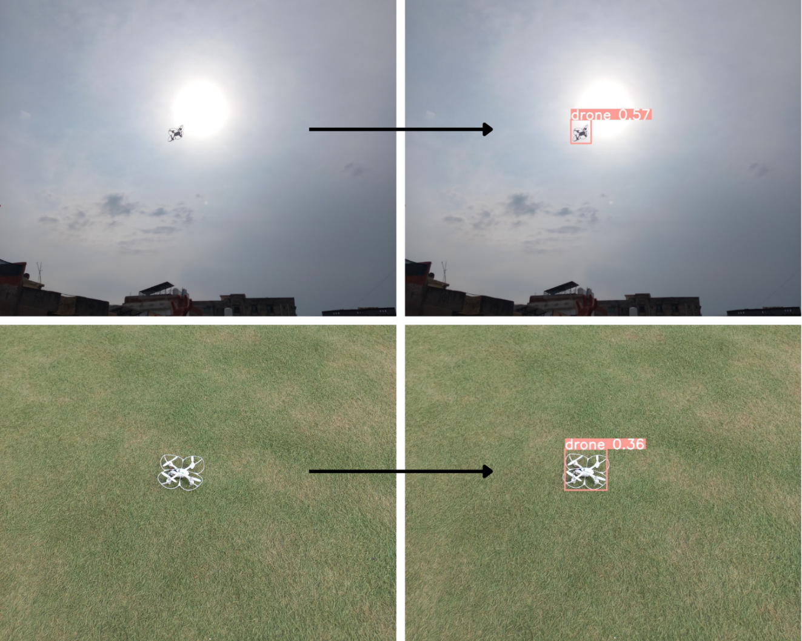We conducted extensive testing using our test-set., which comprises diverse images captured under different backgrounds, lighting conditions, and environments. The test images comprise of our custom and the test set that we obtained from the internet. The YOLOv8 model, trained on this dataset, was evaluated for its ability to accurately detect drones in real-time.

**Figure 7:** Detection on custom test-set

Figure 5 shows detection of drone with bounding box and accuracy. The model was trained on data set that mostly comprised of images taken in sky that’s why accuracy in test set is higher in images of drones that are detected in sky.

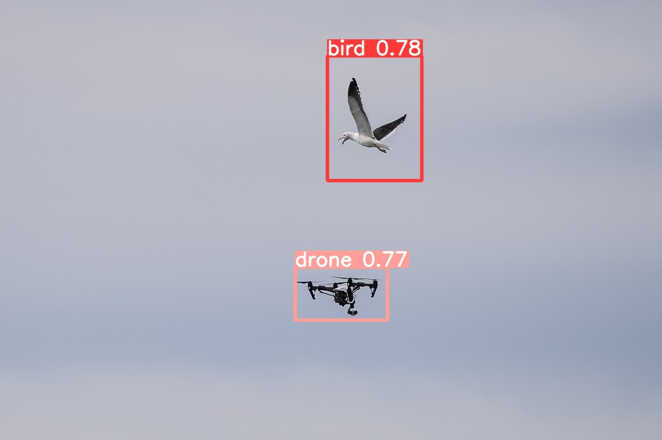

**Figure 8:** Test image detecting drone and bird.

* 1. **Evaluation Metrics:**

Standard object detection criteria, such as precision, recall, and mean Average Precision (mAP), were used to assess the YOLOv8 model's performance. Recall is the percentage of correctly identified drone detections among all real drone instances in the dataset, whereas precision is the percentage of correctly identified drone detections among all detections made by the model. An overall indicator of the model's detection accuracy for several object categories is provided by mAP.

Several evaluation metrics obtained after fine-tuning our model on YOLOv8 are as follows:

* **Confusion Matrix**:

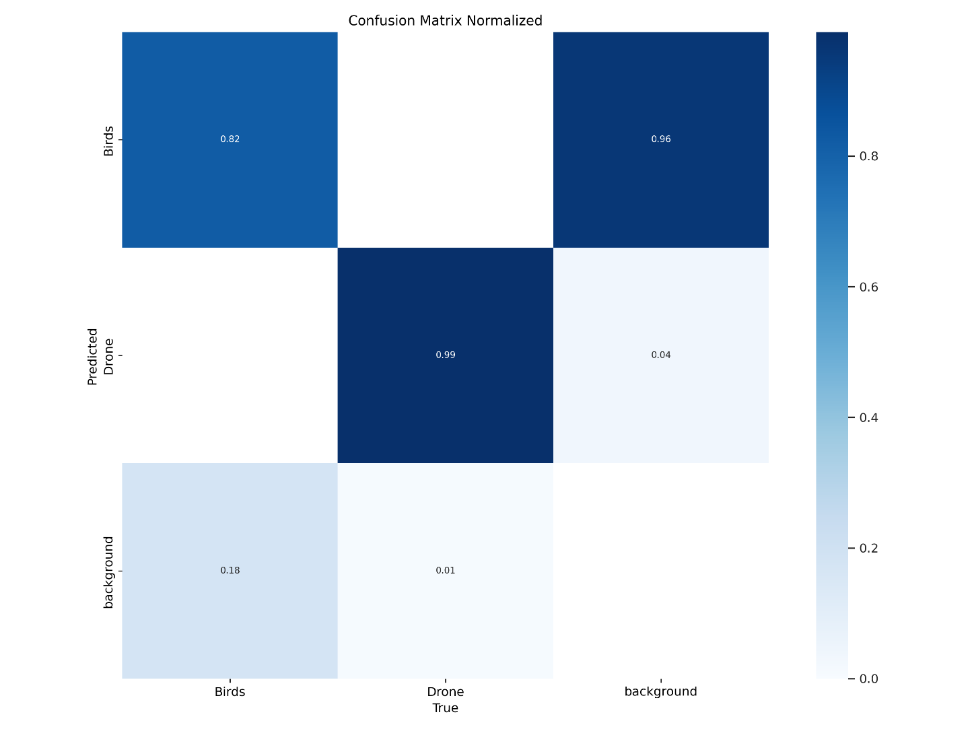

**Figure 9:** Confusion Matrix for drone vs birds.

Figure 6 shows correct classification of drones and birds but there is confusion between birds and background as some of the images in the dataset had missing labels.

* 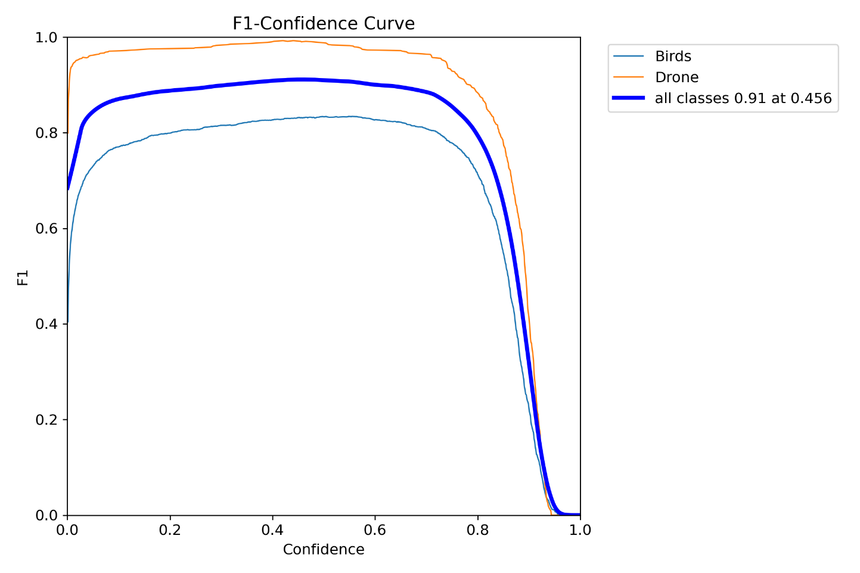**F1 Curve:**

**Figure 10:** F1 Curve for drone vs birds.

Figure 7 shows the curve shows that the model achieves a balanced accuracy (F1-score of 0.71) for all classes (birds and drones) at a confidence level of around 54%. As the confidence threshold increases, the accuracy generally decreases for both birds and drones. This means the model prioritizes high-confidence detections at the expense of potentially missing some birds or drones.

* **Precision -Recall Curve:**

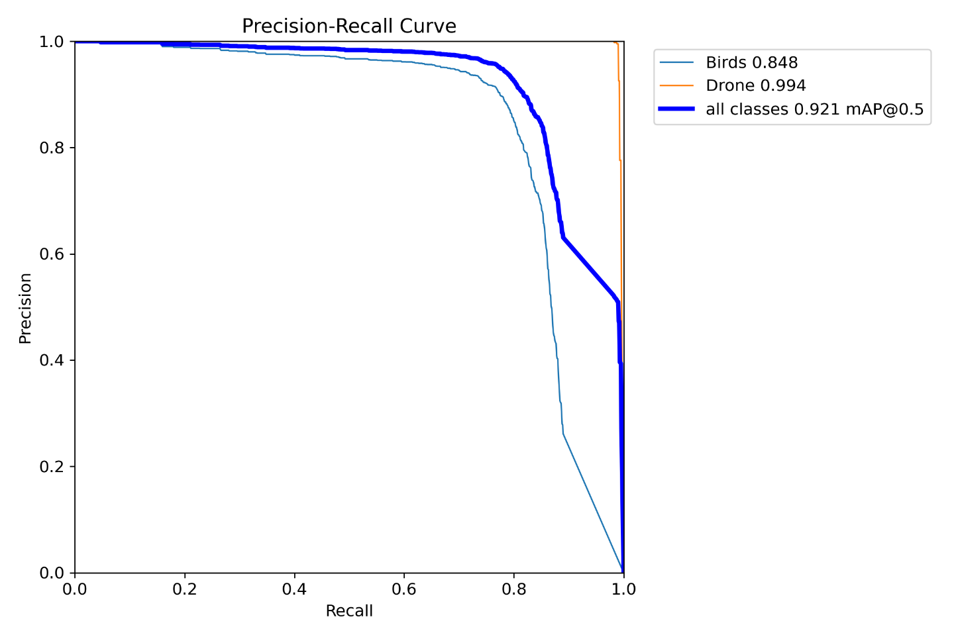

**Figure 11:** Precision recall curve

In Figure 8 precision-recall curve offers insights into the trade-off between accurate detections and capturing all birds and drones. Initially, the model prioritizes precision, meaning many of its early detections are accurate (high precision). However, as the model aims to detect more birds and drones (increasing recall).We can also see the cumulative mAP @0.5 for drone and bird is 0.715 and individually for drone it is 0.860 and for bird is 0.570.

* 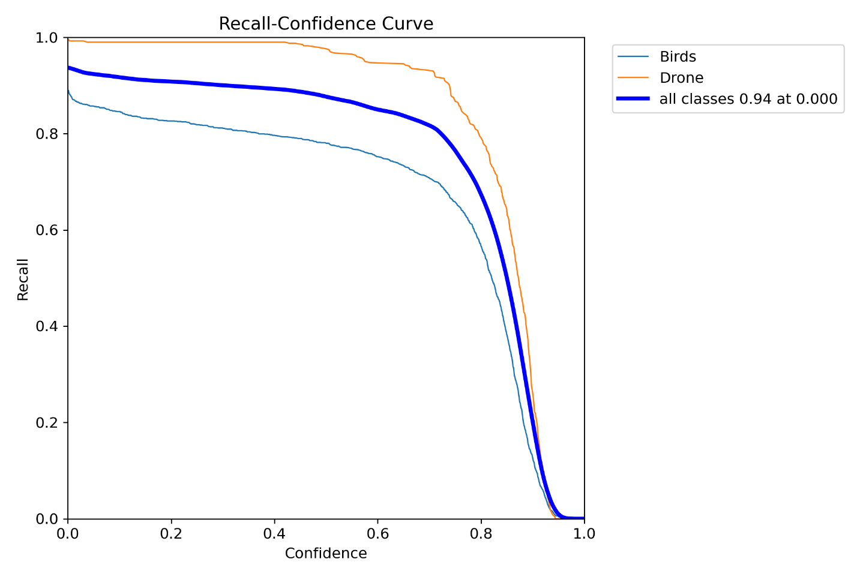**Recall-confidence Curve:**

**Figure 12:** Recall-Confidence curve

The curve focuses on how well the model detects birds and drones (recall) at various confidence levels. As the model's confidence in its predictions increases (moving right on the x-axis), the recall (y-axis) generally decreases. This means the model prioritizes high-confidence detections over finding all birds and drones.

* **Precision-Confidence Curve:**

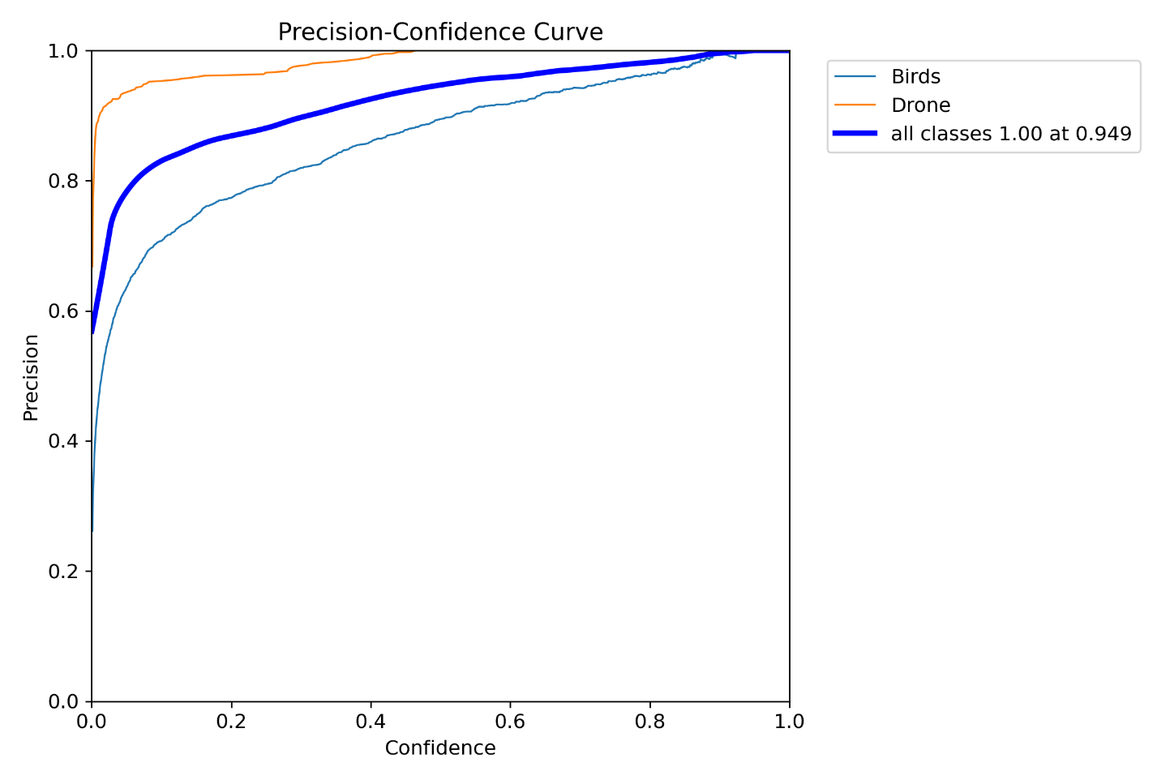

**Figure 13:** Precision-Confidence curve

Figure 10 shows how accurate (precise) the model is at different confidence levels. Initially, the model is good at making precise detections even when not very confident. However, as the model's confidence increases, it starts including more false positives, leading to a decrease in precision. This helps to decide on a confidence threshold: a lower threshold prioritizes catching all birds and drones (potentially with more false positives), while a higher threshold ensures more accurate detections at the expense of potentially missing some birds or drones.

* 1. **Results:**

Our evaluation results indicate that the YOLOv8 model, trained on our custom dataset with yolov8s.pt pretrained weights, achieved promising performance in drone detection. The model demonstrated high precision and recall rates, indicating its ability to accurately identify drone instances in various environmental conditions. Additionally, the mAP score further validates robustness of model in detecting drones across different scenarios.

* 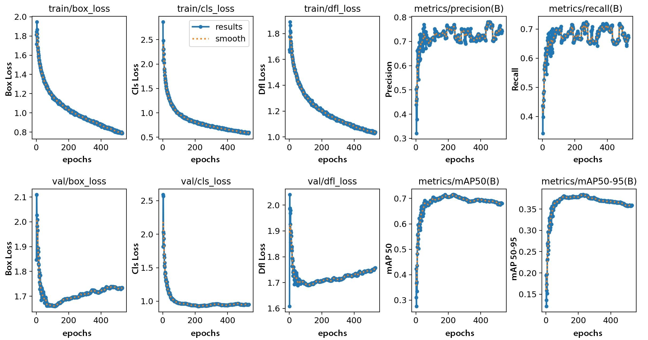**Training Losses:**

**Figure 14 ( a ):**  Figure shows epochs on X axis and Training Losses on Y axis.

* **Validation Losses :**

**Figure 14 ( b ):** Figure shows epochs on X axis and Validation Losses on Y axis.

* **A group of graphs showing the results of a graph

  Description automatically generated with medium confidencePrecision and Recall:**

**Figure 14 ( c ):** Figure shows epochs on X axis and Precision and Recall values on Y axis.

* **mAP50 and mAp50-95:**

**Figure 14 ( d ):** Figure shows epochs on X axis and mAP50 and mAP50-95 on Y axis.

Figure 14 ( a b c d ) shows the different results for our model that includes train and validation losses.(box_loss, cls_loss, df1 loss), mAP50 and mAP50-95 which is the mean average precision.

**Chapter 05**

**Outcomes, Scope, and Conclusion**

* 1. **Outcomes:**

Here are some potential outcomes for your project on drone detection using image classification and deep learning:

* **High Accuracy Detection:** By leveraging image classification techniques and deep learning algorithms, your project aims to achieve high accuracy in detecting drones within various environmental conditions and backgrounds.
* **Real-Time Detection:** One of the primary objectives is to develop a system capable of real-time drone detection, enabling timely response and intervention in scenarios where drones pose security or privacy threats.
* **Robustness to Environmental Factors:** The project aims to create a detection system that is robust to environmental factors such as lighting conditions, weather conditions, and background clutter, ensuring reliable performance in diverse settings.
* **Customizable and Scalable Solution:** The developed solution should be customizable and scalable, allowing for easy integration into existing surveillance systems and adaptation to different deployment scenarios and requirements.
* **Reduction of False Positives:** By employing advanced deep learning algorithms and fine-tuning techniques, the project seeks to minimize false positive detections, thereby enhancing the system's reliability and reducing unnecessary alerts or interventions.
* **Optimization for Resource-Constrained Platforms:** Considering the potential deployment of the detection system on resource-constrained platforms such as embedded devices or edge computing nodes, the project aims to optimize the algorithms for efficient execution and minimal computational overhead.
* **Integration with Existing Infrastructure:** Another outcome is the seamless integration of the drone detection system with existing surveillance infrastructure, enabling synergistic operation and enhancing overall security and situational awareness.
* **Adaptability to Regulatory Requirements:** The project considers regulatory requirements and constraints related to drone detection and ensures that the developed solution complies with relevant regulations and standards.
* **Potential for Further Research and Development:** The project's results provide a solid basis for further study and advancement in the areas of drone detection and picture classification, creating opportunities to investigate cutting-edge methods and cutting-edge applications.
* **Contribution to Security and Privacy:** Ultimately, the project aims to contribute to enhanced security and privacy by providing an effective and reliable solution for drone detection, mitigating potential risks and ensuring the safety of individuals and public spaces.
  1. **Scope:**

The project aims to develop a robust and efficient system for detecting drones using image classification techniques and deep learning algorithms. The system will analyze visual data from surveillance cameras to identify and alert users to the presence of drones in real-time. The scope of this project involves the following:

* **Custom Dataset Creation:** A custom dataset comprising diverse images of drones in different environments and conditions will be created for training and evaluation purposes. The dataset will be annotated with ground truth labels to facilitate supervised learning.
* **Integration with Surveillance Systems:** The developed detection system will be integrated into existing surveillance infrastructure, enabling seamless operation and interoperability with other security systems. This may involve compatibility testing and software integration efforts.
* **Real-Time Detection Implementation:** The system will be designed to perform drone detection in real-time, ensuring timely identification and response to potential security threats. Optimization techniques will be employed to achieve efficient processing and low latency.
* **Performance Evaluation and Testing:** The detection system will undergo extensive testing and evaluation in order to determine its accuracy, dependability, and scalability. Under different circumstances, performance parameters like recall, precision, and detection speed will be assessed.
* **Project Constraints:**
* Hardware limitations such as processing power and Camera resolution.
* Regulatory constraints related to privacy, data protection, and drone usage.
* Budgetary constraints for equipment, software, and resources.
* Time constraints for project completion and delivery.
* **Project Assumptions:**
* Availability of suitable surveillance cameras and hardware for testing and implementation.
* Access to relevant datasets and resources for model training and evaluation.
* The test accuracy of the detection system may vary depending on the prevalence of sky-based images in the dataset.
* **Project Risks:**
* Technical challenges related to algorithm optimization, model training, and system integration.
* Data quality issues such as insufficient or biased training data.
* Security risks associated with system vulnerabilities and unauthorized access.
* External factors such as changes in regulatory requirements or technological advancements.
* **Project Success Criteria:**
* High accuracy and reliability of drone detection, as measured by performance metrics.
* Real-time detection capability with minimal latency and false positives.
* Seamless integration with existing surveillance infrastructure and user-friendly interface.
* Compliance with regulatory requirements and stakeholder expectations.
* Effective documentation and knowledge transfer for system adoption and maintenance.
  1. **Conclusion:**

This project has made significant strides in the development of a drone detection system leveraging image classification and deep learning techniques. Through extensive research, dataset creation, model training, and implementation, we have addressed the pressing need for effective drone surveillance in diverse environments. The integration of state of the art algorithm (YOLOv8), has enabled real-time detection capabilities, enhancing security and situational awareness.

The outcomes of this project demonstrate promising results in terms of accuracy, reliability, and scalability. By focusing on the detection of drones in sky environments, we have achieved notable success in scenarios where drones are prevalent. However, it is essential to acknowledge the limitations and challenges encountered, including the dependency on specific environmental conditions and the need for further optimization in real-world deployments.

Moving forward, continued research and development efforts are warranted to enhance the robustness and adaptability of the detection system. This includes refining algorithms, expanding the dataset to encompass a wider range of scenarios, and addressing regulatory and privacy considerations. Moreover, collaboration with industry partners and stakeholders will be instrumental in refining the technology and facilitating its adoption in practical settings.

In conclusion, this project represents a significant step forward in the field of drone detection, with the potential to contribute to enhanced security, privacy, and safety in drone-frequent environments. With ongoing innovation and collaboration, we aim to further advance the capabilities of drone detection systems and pave the way for a safer and more secure future.

#### 

***Bibliography***

[1] Majeed, R., Abdullah, N.A., Mushtaq, M.F. and Kazmi, R., 2021. Drone security: Issues and challenges. Parameters, 2(5).

[2] M. Z. Anwar, Z. Kaleem, and A. Jamalipour, “Machine learning inspired sound-based amateur drone detection for public safety applications,” IEEE Transactions on Vehicular Technology, vol. 68, no. 3, pp. 2526–2534, 2019. doi: 10.1109/TVT.2019.2893615.

[3] G. J. Mendis, T. Randeny, J. Wei, and A. Madanayake, “Deep learning based doppler radar for micro uas detection and classification,” in MILCOM 2016 - 2016 IEEE Military Communications Conference, 2016. doi: 10.1109/MILCOM.2016.7795448 pp. 924–929.

[4] S. R. Ganti and Y. Kim, “Implementation of detection and tracking mechanism for small uas,” in 2016 International Conference on Unmanned Aircraft Systems (ICUAS), 2016. doi:10.1109/ICUAS.2016.7502513 pp. 1254–1260.

[5] E. Unlu, E. Zenou, and N. Rivière, “Generic fourier descriptors for autonomous uav detection,” in ICPRAM, 2018.

[6] Y. Liu, L. Liao, H. Wu, J. Qin, L. He, G. Yang, H. Zhang, and J. Zhang, “Trajectory and image-based detection and identification of uav,” Vis. Comput., vol. 37, no. 7, p. 1769–1780, jul 2021. doi:10.1007/s00371-020-01937-y.

[Online]. Available: https://doi.org/10.1007/s00371-020-01937-y

[7] Saqib M, Khan SD, Sharma N, Blumenstein M (2017) A study on detecting drones using deep convolutional neural networks In: 2017 14th IEEE International Conference on Advanced Video and Signal Based Surveillance (AVSS), 1–5.. IEEE.

[8] E. Unlu, E. Zenou, N. Riviere, and P.-E. Dupouy, “Deep learning-based strategies for the detection and tracking of drones using several cameras,” IPSJ Transactions on Computer Vision and Applications, vol. 11, no. 1, pp. 1–13, 2019.

[9] Shafiq, K., 2023. Drone Detection and Classification using Machine Learning (Doctoral dissertation, Université d'Ottawa/University of Ottawa).

[10] Liu, Y., 2023. Drone Detection using Deep Learning.

[11] S. R. Ganti and Y. Kim, “Implementation of detection and tracking mechanism for small uas,” in 2016 International Conference on Unmanned Aircraft Systems (ICUAS), 2016. doi:10.1109/ICUAS.2016.7502513 pp. 1254–1260.

[12] Zhai, X.; Huang, Z.; Li, T.; Liu, H.; Wang, S. YOLO-Drone: An Optimized YOLOv8 Network for Tiny UAV Object Detection. Electronics 2023, 12, 3664. https://doi.org/10.3390/electronics12173664

[13] Wang, G.; Chen, Y.; An, P.; Hong, H.; Hu, J.; Huang, T. UAV-YOLOv8: A Small-Object-Detection Model Based on Improved YOLOv8 for UAV Aerial Photography Scenarios. Sensors 2023, 23, 7190. https://doi.org/10.3390/s23167190

#### Appendix

* A screenshot of a computer program

  Description automatically generatedDenseNet169:

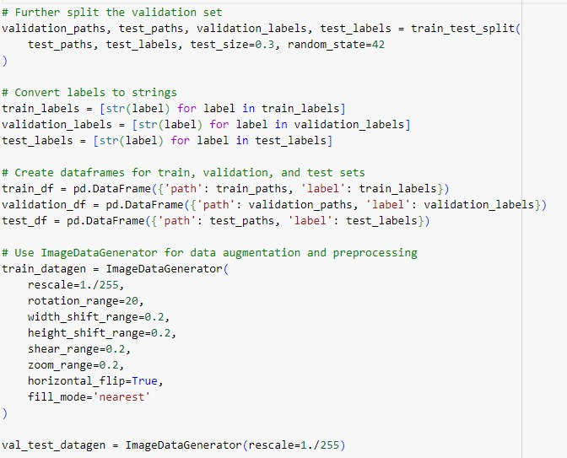



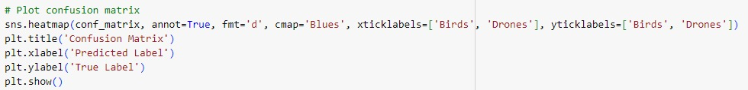

* ResNet152V2:

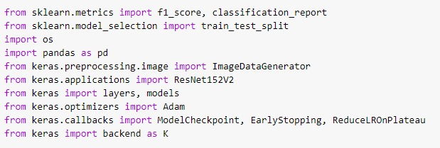

Rest of the code is same as DenseNET169

* 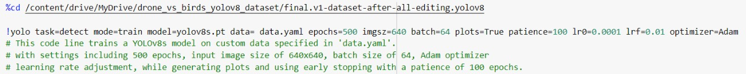YOLOv8 Fine Tuning:





* 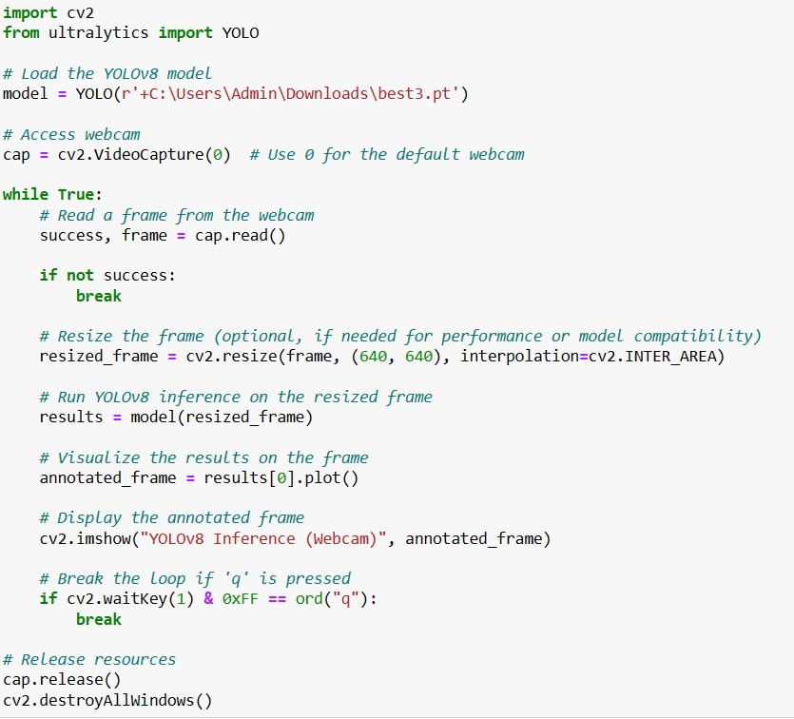Real Time Detection for YOLOv8: